Name | BIH SHENEIDA
Batch | BO83D-Networkwalks
Date | 18th September 2026
Modules completed | W2-PM4  W2-PM5
Target | Microsoft  My own machine

This practical work was carried out to develop my understanding of reconnaissance and network scanning in cybersecurity
Reconnaissance involves gathering information while network scanning involves identifying active host, open ports and available services.
For this practical I completed theHarvester footprinting and zenmap network scanning

W2-PM4
Tool: theHarvester
Objective: to collect publicly available information with a domain
Target: Microsoft.com
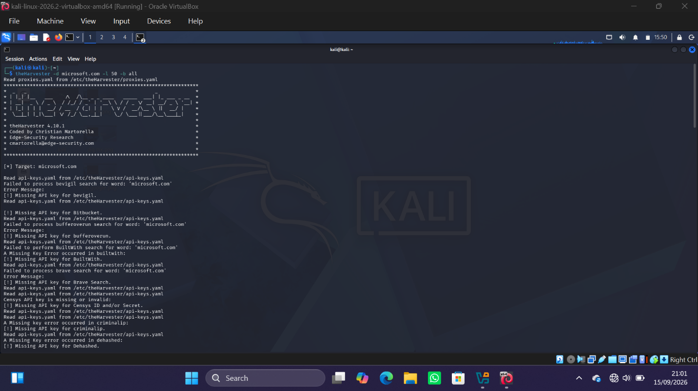

W2-PM5

Tool: Zenmap
I launched a regular Nmap scan from Zenmap against my machine ip.
The scan identified three live host
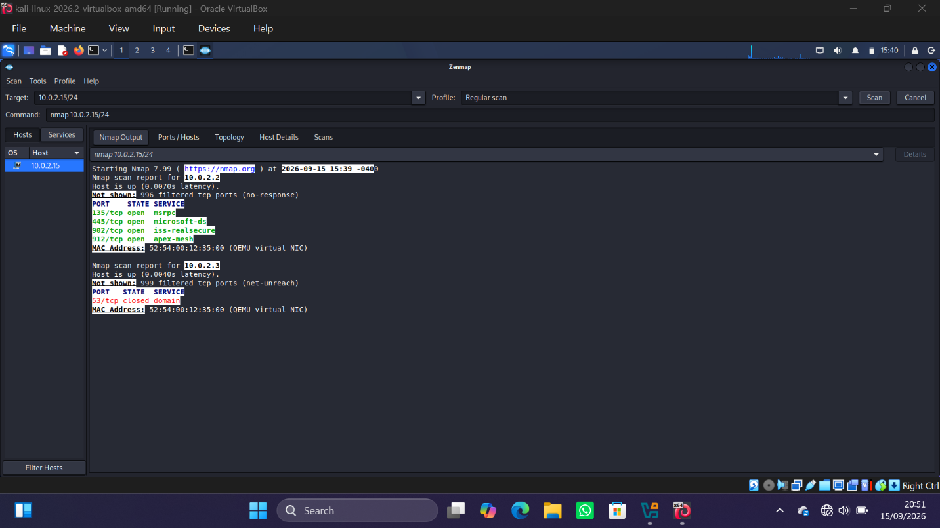

I used the topology tab in Zenmap to visualize the discovered hosts and their relationship to the scanning machine.
The graphic below shows the local host at the center, connected to the three discovered host on the network
